Work plan

Deadlines
- 2016-02-29 Choose a project proposal and send the result via email to epsatisep@gmail.com
- 2016-03-08 Define the Tasks (what must be done - all members must participate in all tasks), subtask allocation (who does what) and Gantt chart (when) of the project and insert them on the wiki (planning)
- 2016-03-14 Upload the “black box” System Diagrams & Structural Drafts to the wiki
- 2016-03-29 Upload the detailed System Schematics & Structural Drawings to the wiki and finish the cardboard scale model of the structure
- 2016-04-04 Upload the List of Materials (what & quantity) to the wiki
- 2016-04-11 Complete the List of Materials (local providers & price - including VAT and transportation) to the wiki
- 2016-04-16 Upload the Interim Report and Presentation to the wiki. The report must contain the Introduction, including the tasks, team members allocation and Gantt chart, State of the Art, Marketing Plan, Project Management, Eco-eficiency Measures for Sustainability, Ethical and Deontological Concerns, Proposed Solution and Bibliography chapters
- 2016-04-21 Interim Presentation, Discussion and Peer, Teacher and Supervisor Feedbacks
- 2016-04-29 Upload refined Interim Report (based on Teacher & Supervisor Feedbacks)
- 2016-05-30 Upload the Functional Tests' Results to the wiki
- 2016-06-11 Upload the Final Report, Presentation, Video, Paper, Poster and Manual
- 2016-06-16 Final Presentation, Individual Discussion and Assessment
- 2016-06-21:
  - Update the wiki with all correction suggestions
  - Hand in a CD with the corrected deliverables (source + PDF) together with all code produced to the EPS coordinator
  - Hand in one printed exemplar of the corrected report to the EPS coordinator
- 2016-06-23:
  - Hand in the prototype and user manual to the client
  - Receive the EPS@ISEP certificate

Tasks
Task | Responsible
Planning
Find the tasks | All
Create the Gantt | All
System Diagrams & Structural Drafts | Alvaro
System Schematics & Structural Drawings | Alvaro
Research
Physical Characteristics Fish | Martin, Alvaro
Programming Research | Achim
Targets | All
Design | Terry, Alvaro
Engineering Development | Terry, Martin
State of the Art | All
Marketing Study
Compare suppliers | Justyna
Compare budget and the project | Justyna
Modifications | All
Materials
What | Achim, Terry
Quantity | Achim, Terry
Prototyping
Materials | All
Design | Terry, Alvaro
Construction | All
Functional Tests | All
Improvement/modification | All
Report/Presentation
Upload Final Report, Presentation, Video, Paper, Poster, Manual and Website | All
Final Presentation, Individual Discussion and Assessment | All
Wiki
Update the wiki with all correction suggestions | All
Hand in a CD with the corrected deliverables together with all code produced to the EPS coordinator | All
Hand in one printed exemplar of the corrected report to the EPS coordinator | All
Final Submission
Hand in the prototype and user manual | All
Certificate | All

Gantt Chart
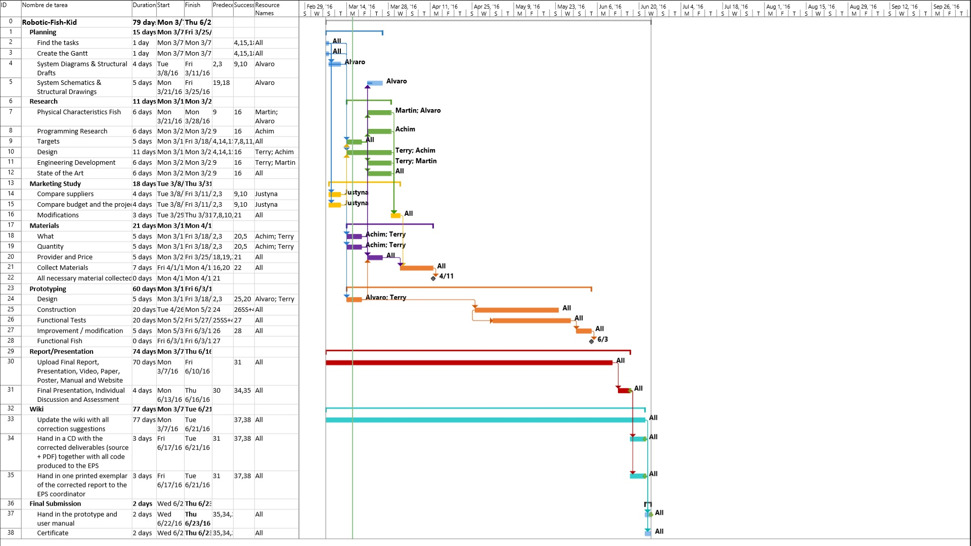

System Diagram
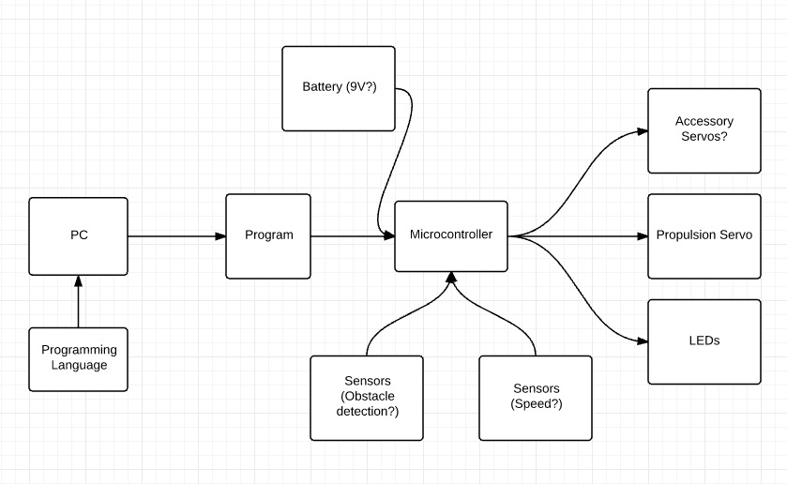

Electronic Schematic


