
DIDACTIC ROBOT FISH
BUBBLES USER MANUAL
Team 3

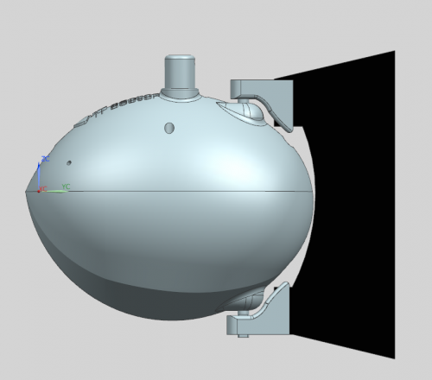

Justyna Urbanksa, Martin McPhee, Terry Greene, Achim Reinhardt, Alvaro Chousa Esteban

Contents

- The Product

- Parts List

- The Battery

- Systems schematics

- Using Bubbles

- Software

The Product

Thank you for purchasing our product. Bubbles is a unique educational toy enabling fun for children between the ages of five and ten. Now you are only a few steps away from interacting with the toy. This product will provide your child with not only educational development but also allowing them to have fun at the same time, this is vital for learning. Please read the manual carefully before using Bubbles, our product is safe however not paying attention to detail or inappropriate use could result in an injury. Once this has been completed there is a simple and easy installation procedure to take place and then you are ready to begin the fun with Bubbles.

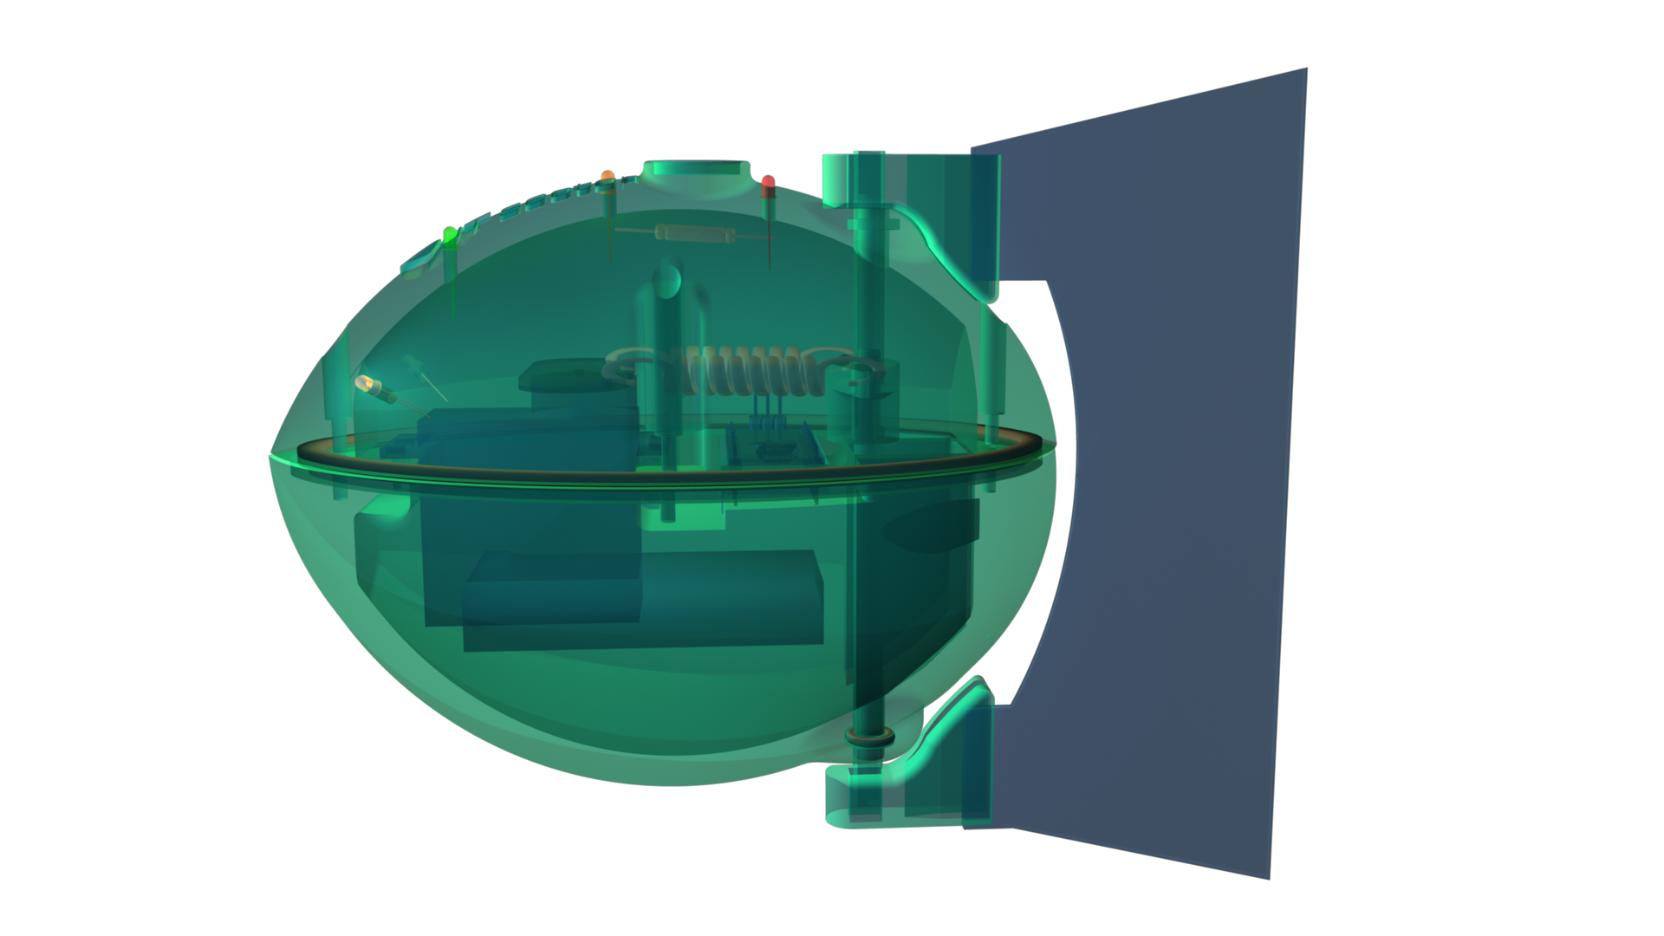

Parts List

Bubbles contains several important parts that are essential to its operation. These parts are as follows:
- Arduino Nano Board
- 7.4 V/900mAh Battery
- DF15 servo motor
- Reed Switch
- Charger
- 3 LED lights for feedback
- RGB LED light for eyes
- Appropriate cabling
- A charger

The Battery

In the unfortunate case where you are experiencing difficulties with the battery, it is essential that you do not try to open or attempt to fix the problem yourself. Please contact a member of our team and they will be more than willing to assist you to solve the problem. We insist that you do not attempt to tackle this problem as it could be unsafe and we have experienced technical members on hand to help.

In order to successfully charge the battery, simply connect the adapter to the 7.4 V/ 900mAh battery and a light should appear on. Connect this to the fish and a second light should now turn on indicating that the battery is being charged.

System Schematics

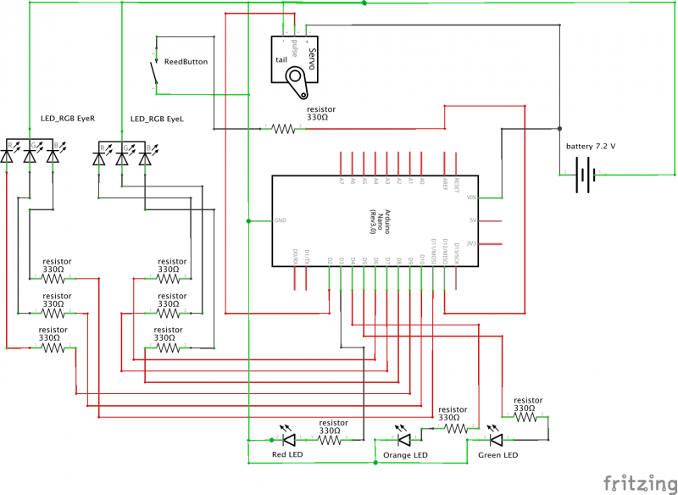

Using Bubbles

Bubbles has now been fully charged, it is time to place your toy into the aquatic are of your choice. When Bubbles has entered the water it is now possible to control the movements by using the simply programming language from ardu-block that has been developed. You can now control Bubbles movement allowing the robot to move forward, left and right.
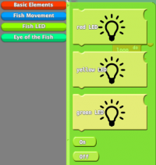
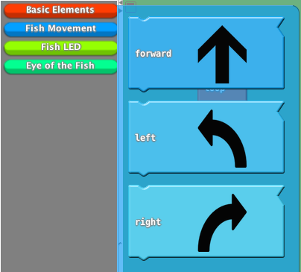

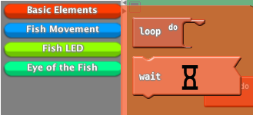

Software

Install Arduino
The communication between the robot and programming software is realized by Arduino. For that the newest version of Arduino has to be installed. It can be find on https://www.arduino.cc/en/Main/Software. Follow the instructions of the website.

Add Aquablock to Arduino
The software Aquablock is specially designed for the requirements of Bubbles. It operates as a plugin for Arduino and communicates directly with Arduino.
Perform the following steps to add Aquablock to the Arduino IDE:
- Download Aquablock from our website. (link)
- Open the menu preferences. Arduino -> Preferences
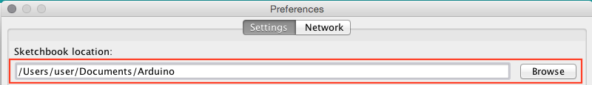
- Find “Sketchbook location”:
  - Default Mac: “Documents/Arduino”
  - Default Linux: “sketchbook”
  - Default Windows: “Documents\Arduino”
- Copy the file “aquablock.jar” to the following location in the Sketchbook location:
“tools/ArduBlockTool/tool/aquablock.jar”
The resulting path can be like that:
  - Mac: “/Users/user/Documents/Arduino/tools/ArduBlocktTool/tool/aquablock.jar”
  - Linux: “/home/user/sketchbook/tools/ArduBlockTool/tool/aquablock.jar”
Windows: “C:\Users\user\Documents\Arduino\tools\ArduBlockTool\tool\aquablock.jar”

Start Arduino, you should find find Aquablock in the tool menu

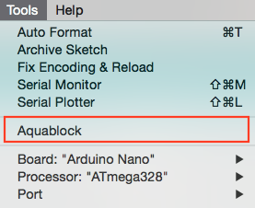

Using Ardublock:
After successfully installing Arduino and adding Aquablock, you can start programming the robot. The following frame appears when you open Aquablock
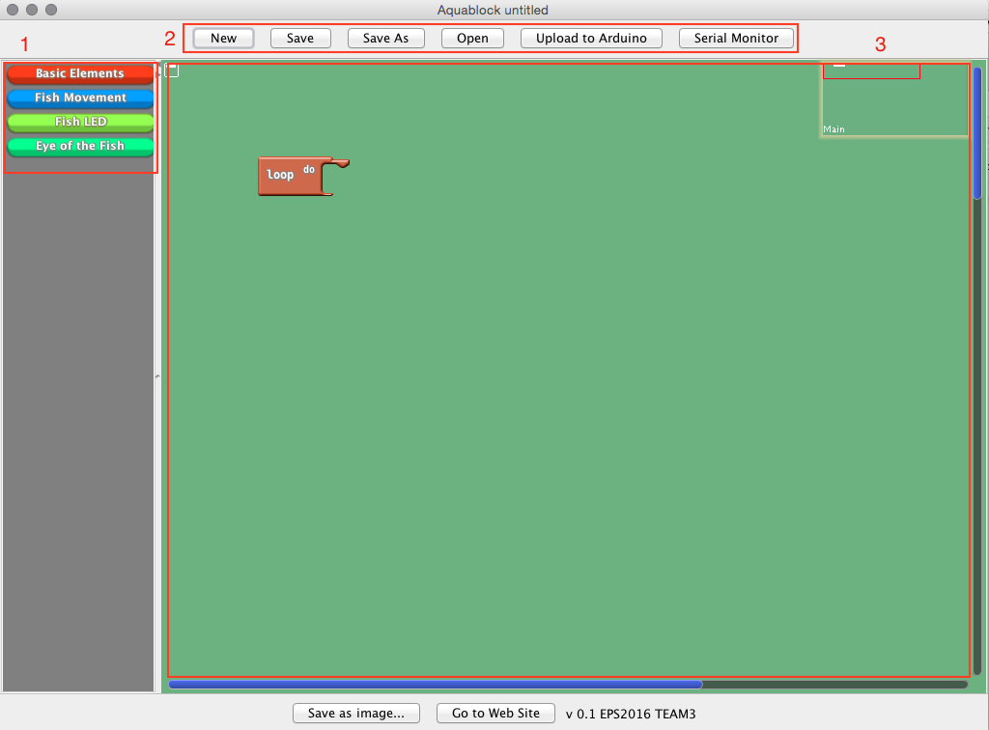

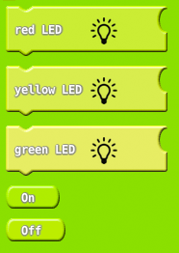

In this category you find all blocks to control the red, yellow and green LED. Depending on the connected block the color LED will turned on or off.

Eyes of the Fish
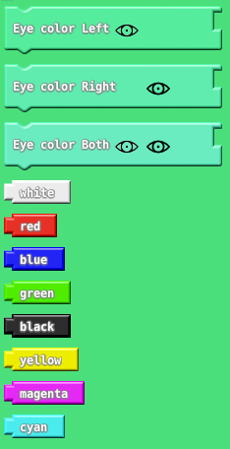

With these elements the color of one or both eyes of the fish can be set. The related colors are also in this categories and can be connected to the eye blocks.

